THE 27th INTERNATIONAL BADMINTON

CUP 2012

YOUTH TEAMS TOURNAMENT

Named Entry Form

Team: Badminton Team Sachsen

Players

Name | Surname | Born | Male/Female
Hofmann | Pit | 97 | Male
Stock | Benjamin | 97 | Male
Adam | Laura | 97 | Female
Räder | Judith | 98 | Female

Coaches

Name | Surname | Male/Female
Adam | Stefan | Male

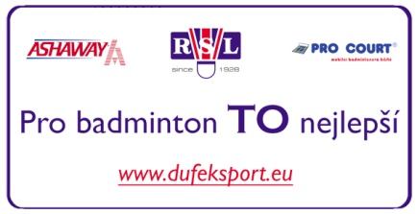
Date: 02.05.2012

_______________________________________
Signature

