
INVITATION FOR THE 25th INTERNATIONAL BADMINTON

CUP 2010

YOUTH TEAMS TOURNAMENT

Organizer: Badminton Club Cesky Krumlov & VICTOR CZ
www.badmintonckrumlov.cz www.victor.cz

Venue: Sports Hall Cesky Krumlov, Chvalsinska 111, 381 01 Czech Republic

Dates: 11. – 13. June, 2010

Entry forms: to be sent by fax to: 00 420 222 590 569
or by email: victor@victor.cz and radek.votava@mybox.cz
Entry deadline: May 1st 2010

System of play:
- groups (teams in each group shall play each other to determine the final ranking)
- each tie consists of five matches (MS, WS, MD, WD, XD)
- each player may play a maximum of two matches in one tie
Scoring System: Rally Point Scoring 3 x 21 points

Eligible players: U-15; born 1995 and younger

Shuttlecocks: natural feather, provided by the organizer

Accommodation & boarding: Accommodation in guesthouses, pensions;
Food during the tournament is provided by organizer

Entry-fees: 50 € per participant (per each player and team leader).
The entry-fee includes:
- accommodation on Friday (11.5.) and Saturday (12.5) nights
- food (dinner Friday; breakfast, lunch buffet and dinner Saturday; breakfast and snack Sunday)
- water, drinks
- shuttles, prizes





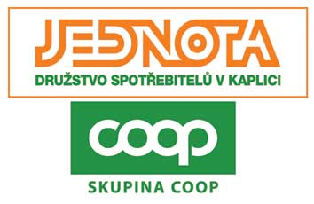








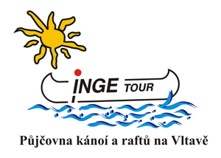


- swimming pool free of charge on Friday and Saturday evening

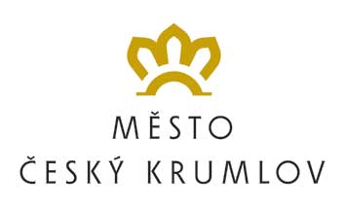
Prizes: Cups and Souvenirs.
Partners SK Badminton Český Krumlov

