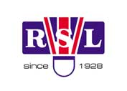
THE 27th INTERNATIONAL BADMINTON

CUP 2012

YOUTH TEAMS TOURNAMENT

Named Entry Form

Team: Lokomotíva Košice

Players

Name | Surname | Born | Male/Female
Adam | Horak | 6.2.99 | M
Peter | Hrnčár | 27.5.99 | M
Lenka | Drotárová | 16.7.98 | F
Michaela | Lukačinová | 13.1.97 | F
Katarína | Vargová | 13.4.99 | F

Coaches

Name | Surname | Male/Female
Ján | Fiľ | M
Vladimír | Turlik | M

Peter | Hrnčar | M

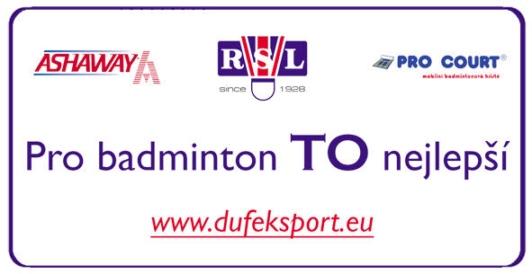
Date: …………………………

_______________________________________
Signature

