
THE 27th INTERNATIONAL BADMINTON

CUP 2012

YOUTH TEAMS TOURNAMENT

Named Entry Form

Pilsen Team

Players

Name | Surname | Born | Male/Female
Jan | LOUDA | 25.4.1999 | M
Radek | PISTULKA | 20.7.1997 | M
Kateryna | VATASHCHUK | 28.4.1997 | F
Jana | PANOCHOVA | 26.4.1997 | F

Coaches

Name | Surname | Male/Female
Lenka | PISTULKOVA | F

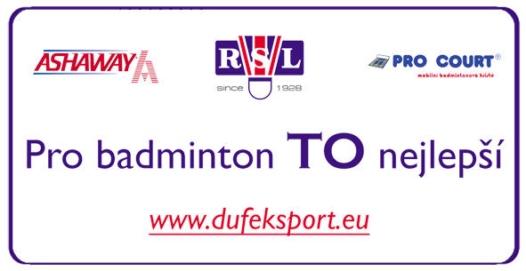
Date: 16.5.2011

Milada Nováková, 602169692,
miladanovakova@centrum.cz
_______________________________________
Signature

