
THE 27th INTERNATIONAL BADMINTON

CUP 2012

YOUTH TEAMS TOURNAMENT

Named Entry Form

Team: SK Badminton Český Krumlov “A”

Players

Name | Surname | Born | Male/Female
Marek | Jakeš | 1999 | Male
Nicola | Siviglia | 2000 | Male
Tereza | Markovcová | 1999 | Female
Daniela | Jakešová | 1999 | Female

Coaches

Name | Surname | Male/Female
Radek | Votava | Male
Pavel | Florián | Male


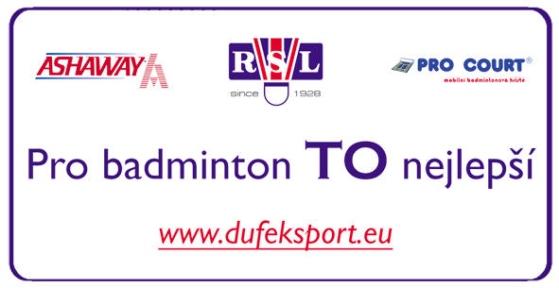
Date: 5.5.2012

_______________________________________
Signature

