
THE 27th INTERNATIONAL BADMINTON

CUP 2012

YOUTH TEAMS TOURNAMENT

Named Entry Form

Team: SK Badminton Český Krumlov “B”

Players

Name | Surname | Born | Male/Female
 |  |  | Male
 |  |  | Male
Sabina | Milová | 1997 | Female
Valentýna | Gutvirthová | 1997 | Female

Coaches

Name | Surname | Male/Female
Radek | Votava | Male
Pavel | Florián | Male

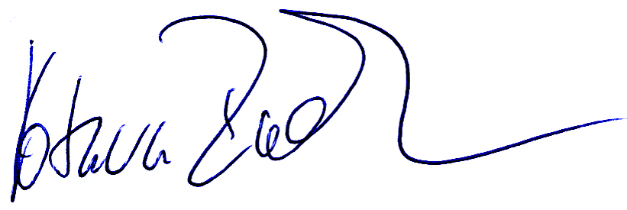
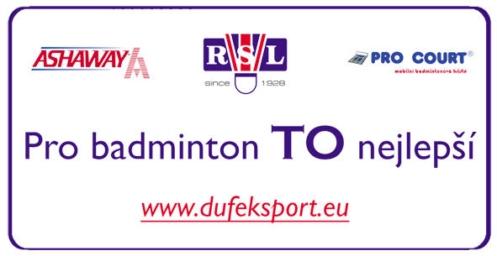
Date: 5.5.2012

_______________________________________
Signature

