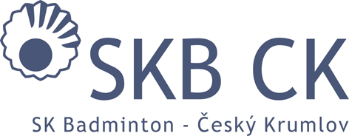
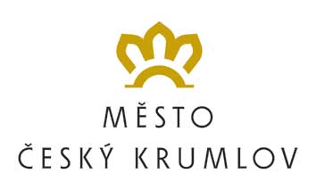
HLAVNÍ PARTNER KLUBU

SK Badminton Český Krumlov
In co-operation with PRO-SPORT ČK o.p.s.
FZ Forza Summer Camp 2016
(31. 7. – 6. 8. 2016)

GOOD HEALTH STATE DECLARATION – hand in upon arrival!!!

I hereby declare, that my son / daughter …………………………….. who has entered the FZ Forza SUMMER CAMP 2016 (the event will take place from 31st July to 6th August 2016) doesn´t suffer from any health problems, which would prevent him from participating at the camp or even endanger his life.

My son / daughter suffers from other difficulties, which need to be taken into account (asthma, alergies, etc.):
…………………………………………………………………………………………………………………………………………………………………………………………………….

Date: ……………………………….

Signature: ……………………….

