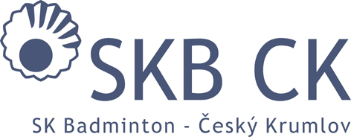
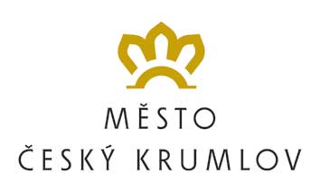
HLAVNÍ PARTNER KLUBU

SK Badminton Český Krumlov
In co-operation with PRO-SPORT ČK o.p.s. and FZ Forza Czech Republic
FZ Forza Summer Camp 2017
(30 July – 5 August 2017)

GOOD HEALTH STATE DECLARATION – hand in upon arrival!!!

I hereby declare, that my son / daughter …………………………….. who has entered the FZ Forza SUMMER CAMP 2016 (the event will take place from 30th July to 5th August 2017) doesn´t suffer from any health problems, which would prevent him from participating at the camp or even endanger his life.

My son / daughter suffers from other difficulties (asthma, alergies, etc.), which need to be taken into account during the practice:
.......................................................................................…………………………………………………………………………………………………………………………………………………………………………………………………….

Date: ……………………………….

Signature: ……………………….

