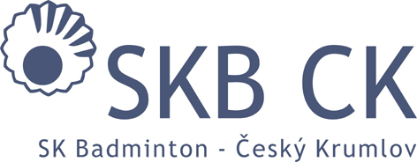
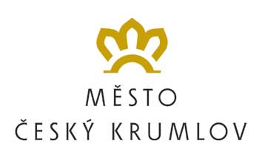
HLAVNÍ PARTNER KLUBU

Sportovní klub Badminton Český Krumlov,z.s.
In co-operation with PRO-SPORT ČK o.p.s. and FZ FORZA Czech Republic
FZ FORZA Summer Camp 2018
(29 July – 4 August 2018)

GOOD HEALTH STATE DECLARATION – hand in upon arrival!!!

I hereby declare, that my son / daughter …………………………….. who has entered the FZ Forza SUMMER CAMP 2018 (the event will take place from 29th July to 4th August 2018) doesn´t suffer from any health problems, which would prevent him from participating at the camp or even endanger his life.

My son / daughter suffers from other difficulties (asthma, alergies, etc.), which need to be taken into account during the practice:
.......................................................................................…………………………………………………………………………………………………………………………………………………………………………………………………….

Date: ……………………………….

Signature: ……………………….

